Project Design Phase-II
Data Flow Diagram & User Stories
Date | 12 October 2026
Team ID | 323103282097.aswija@gvpcew.ac.in
Project Name | ServiceNow Employee Raise Issue Portal
Maximum Marks | 4 Marks
Data Flow Diagrams:
A Data Flow Diagram (DFD) shows how information moves between the employee, the ServiceNow portal and the issue-record data store.
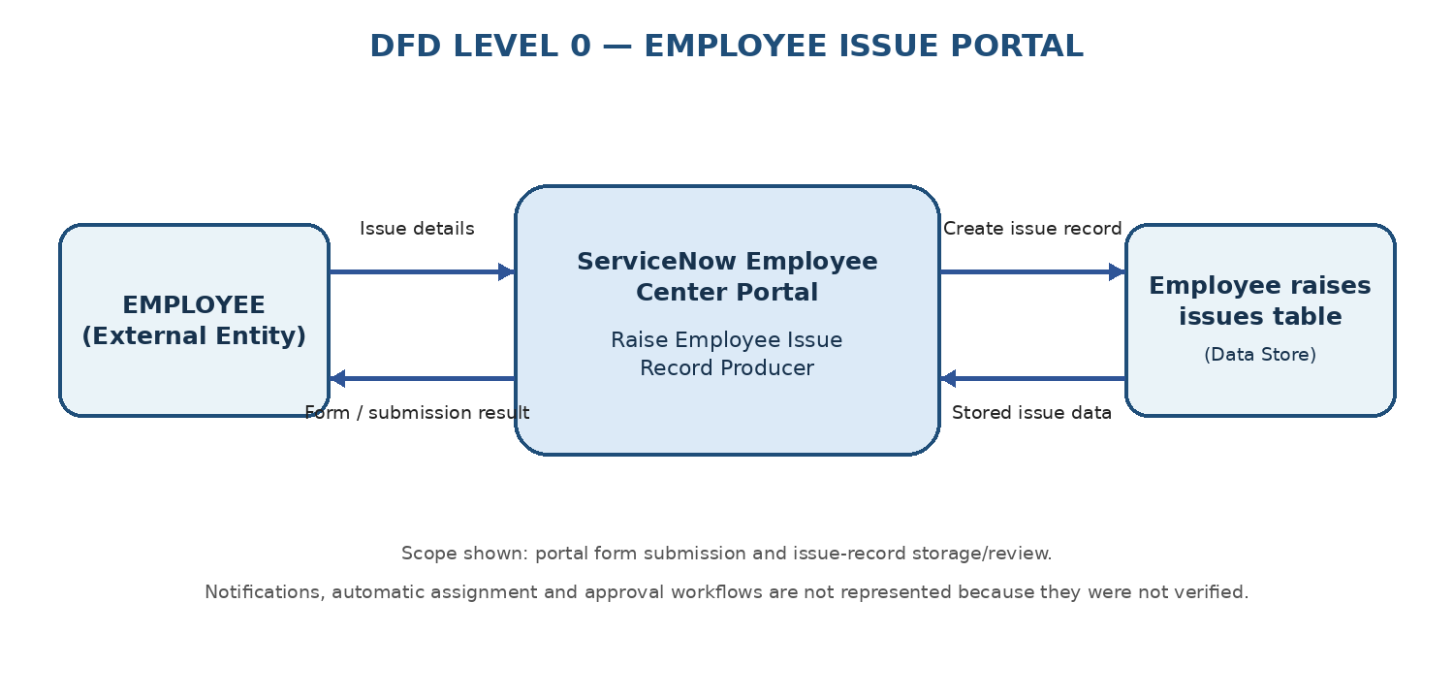
Figure 1. Level 0 DFD for the Employee Raise Issue Portal

DFD Level 1 — Submission Flow
Process | Data flow / outcome
1. Open portal | Employee opens Employee Center and selects Raise Ticket.
2. Enter issue details | The Raise Employee Issue record producer collects requester, category, subcategory, short description and state.
3. Submit | Employee submits the record producer form.
4. Store record | ServiceNow creates an issue record in the Employee raises issues table and assigns a generated record number.
5. Review | The issue record can be viewed in the table list for tracking.

Project Design Phase-II
User Stories

The following user stories describe the verified portal functionality and the basic record-review workflow. Priorities and releases are proposed planning values, not existing ServiceNow configuration.
User Type | Functional Requirement (Epic) | User Story Number | User Story / Task | Acceptance criteria | Priority | Release
Employee | Raise an issue | USN-1 | As an employee, I can open the Raise Employee Issue form from the Employee Center portal so that I can report an issue. | The Raise Ticket button opens the issue form. | High | Sprint-1
Employee | Enter issue details | USN-2 | As an employee, I can enter my requester name, category, subcategory, short description and issue state. | The form displays the available fields and allows the employee to submit issue details. | High | Sprint-1
Employee | Classify issue | USN-3 | As an employee, I can select an issue category and a related subcategory to describe the problem. | Category choices include Network, Software, Hardware and Access; subcategory choices are available on the form. | High | Sprint-1
Employee | Submit issue | USN-4 | As an employee, I can submit the completed issue form so that the issue is recorded in ServiceNow. | A new record is created in the Employee raises issues table and has a generated issue number. | High | Sprint-1
Employee | Attach supporting image | USN-5 | As an employee, I can provide a supporting image with my issue when needed. | The form provides an attachment area; attachment handling should be validated during testing. | Medium | Sprint-2
Support / ServiceNow user | Review submitted issues | USN-6 | As an authorized ServiceNow user, I can view submitted issues in the Employee raises issues table. | The list shows available fields such as Number, Category, Subcategory, State, Priority, Requester, Assignment Group and Short description. | High | Sprint-1
Support / ServiceNow user | Track issue state | USN-7 | As a support user, I can identify an issue's current state from the issue record. | The record list displays the state values configured for the form, including New, In progress, Resolved and Closed. | Medium | Sprint-2

